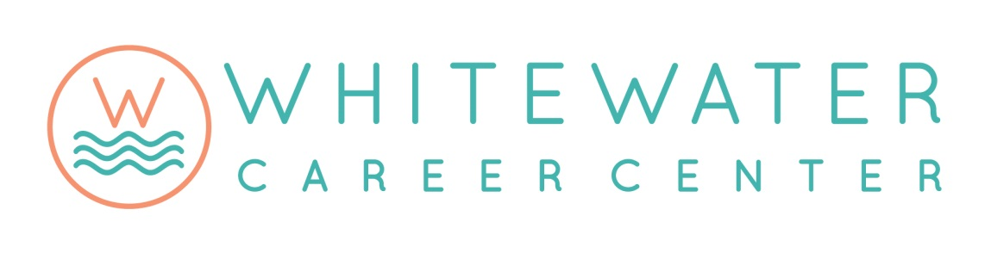

Points of Pride
2016-17

ENROLLMENT
- Enrollment is up 3.6% over last year.
- 568 students enrolled in the 13 programs.

DUAL CREDITS
- Dual credits earned by students increased by more than 62%.
- 77% of WCC students earned dual credit.
- Students saved almost $500,000 on tuition and textbooks (based on Ivy Tech tuition costs).
- 11 new courses were added in 2016-17, and 5 new courses are planned for 2017-18.

CERTIFICATIONS
- Graphic Design added an additional Adobe certification.
- Diesel Technology partnered with Cummins to offer industry certifications to students.

PROGRAMMING
- The Information Technology curriculum now includes expanded certification testing and devise repair, including phones, tablets, and laptops.
- WCC was approved as a NCCER (National Center for Construction Education and Research) training site for the Construction Technology and Electricity programs.

NATIONAL TECHNICAL HONOR SOCIETY
- 51 student members were recognized at the March ceremony.
- Membership is up 82% over last year.

SKILL CONTESTS
- 5 students had first place finishes at the SkillsUSA state competition.
- 5 students advanced to the national SkillsUSA competition.

GRANTS & DONATIONS
- WCC received 5 competitive grants and other donations for equipment and supplies.
- Funds received total $14,511.

