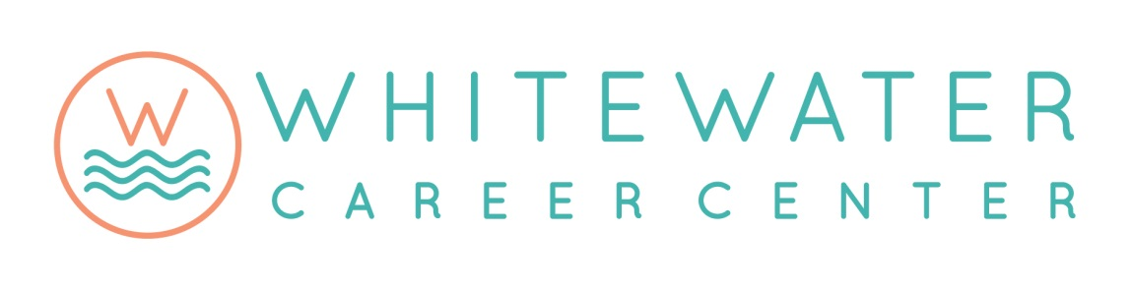

Points of Pride
2015-16

DUAL CREDITS
- Dual credits earned by students increased by more than 20%.
- Students saved more than $300,000 on tuition and textbooks.
- Two new courses are planned for 2016-17.

CERTIFICATIONS
- Two new industry certifications were added in Information Technology.
- Two additional industry certifications are planned for 2016-17 in Information Technology.

NATIONAL TECHNICAL HONOR SOCIETY
- The WCC chapter was created.
- Twenty-eight students were inducted.

SKILL CONTESTS
- Two students were state champions at SkillsUSA – Automotive Refinishing and Technical Math.
- Two students placed first at the Midwest Welding Tournament in GMAW and Theory.

REBRANDING
- The Career Center was rebranded with a new name and logo.
- The rebranding also includes a new website, two videos, a brochure, and a flyer.

PROGRAMMING
- The Education Careers curriculum has been broadened to include elementary education.
- The Information Technology curriculum now includes expanded certification testing and devise repair, including phones, tablets, and laptops.
- The Automotive Technology program was recertified by ASE/NATEF until 2021.

“ACCESS” PROGRAM
- Sophomore students now have the opportunity to attend WCC through the new “Accelerated Career and Cooperative Education for Sophomore Students” program.
- Twenty-nine students are enrolled for 2016-17.

FACILITIES
- WCC has increased security.
- Several instructional areas have been updated.
- The Harmony 3 student data management system has been implemented.

GRANTS
- WCC has received 4 competitive grants for equipment and supplies.
- Grant amounts total $103,627.

